

**S.I.E.S College of Arts, Science and Commerce(EAutonomous) Sion(W), Mumbai – 400 022.**

**CERTIFICATE**

This is to certify that ~~Miss.~~/Mr **Sreenath Shankaran Nair** Roll No. **SCS2526051**_ has successfully completed the necessary course of experiments in the subject of **Operating System** during the academic year **2025 – 2026** complying with the requirements of **University of Mumbai**, for the course of **SYBSc Computer Science [Semester-III].**

**Prof. In-Charge**

**Mrs Maya Nair**

**Examiner’s Signature & Date**

**Head of the Department College Seal Dr. Manoj Singh**

INDEX

| PRACTICAL NO | DATE | NAME/ AIM | SIGN |
| --- | --- | --- | --- |
| 1 | 01-07-2025 | Program to display Summation of numbers using thread. |  |
| 2 | 01-07-2025 | Program to display the prime numbers using thread |  |
| 3 | 01-07-2025 | Program to display the Fibonacci series using thread. |  |
| 4 | 01-08-2025 | Inter-Process Communication Using Multiprocessing.Demo Module |  |
| 5 | 01-08-2025 | Inter-Process Communication Using Multiprocessing. |  |
| 6  7 | 01-08-2025 15-08-2025 | Application On The Fcfs Algorithm  Python Application To Simulate Process Synchronisation Using Semaphorre |  |
| 8 | 23-09-2025 | A) LINUX BASIC COMMANDS  B) SHELL SCRIPTING 1: Write a shell script to perform the following commands on the current working directory  1. Long listing of all files in the pwd  2. To display the current system date  3. Count the number of lines, words, bytes, of the files  4. To display the current user |  |
| 9 | 25-09-2025 | SHELL SCRIPTING 2: Write a shell script to accept a number and display the summation of the number |  |
| 10 | 25-09-2025 | SHELL SCRIPTING 3 :Write a shell script to accept the total marks and out of marks and calculate the percentage and display the grade of the student |  |
| 11 | 25-09-2025 | SHELL SCRIPTING 4 : Write a menu driven shell script to perform various arithmetic operations like addition, subtraction, multiplication and division on two numbers as per user’s choice. (Use case statements ) |  |

**Practical-1,2 & 3**

**Roll no: SCS2526051**

**Aim: Programs on concept of Multithreading A)Program to display Summation of numbers using thread.**

Code:

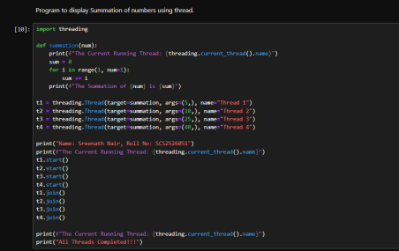

Output:

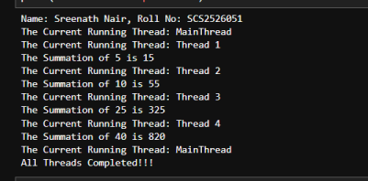

**B) Program to display the prime numbers using thread**

Code:

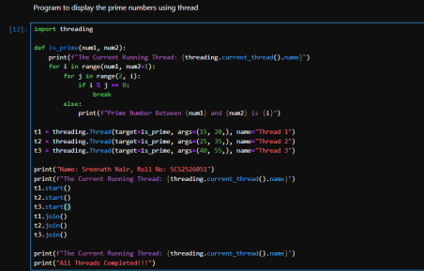Output:

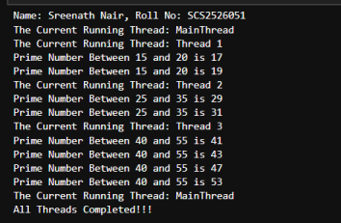

**C) Program to display the Fibonacci series using thread.**

Code:

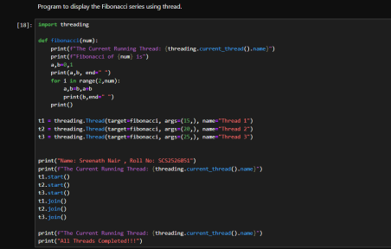Output:

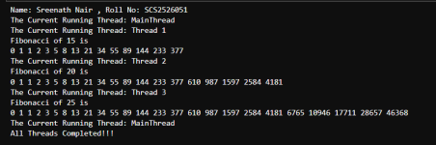

**PRACTICAL-4,5**

**ROLL NO: SCS2526051**

**NAME: SREENATH SHANKARAN NAIR**

**AIM: PROGRAM FOR INTER PROCESS COMMUNICATION**

**4) INTER-PROCESS COMMUNICATION USING**

**MULTIPROCESSING.DEMO MODULE**

**CODE:**

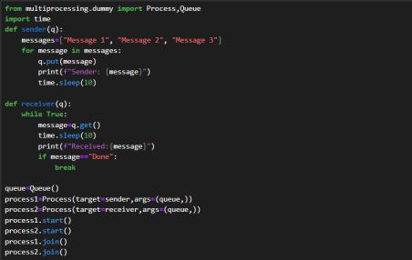**OUTPUT:**

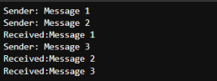

**5) INTER-PROCESS COMMUNICATION USING**

**MULTIPROCESSING.**

**CODE:**

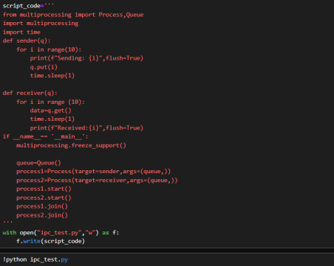**OUTPUT:**

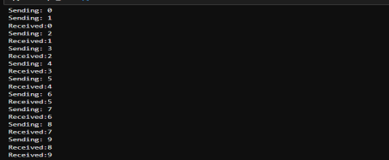

**PRACTICAL- 6**

**ROLL NO: SCS2526051**

**NAME: SREENATH SHANKARAN NAIR**

**AIM: APPLICATION ON THE FCFS ALGORITHM**

**CODE:**

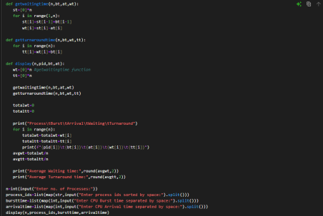**OUTPUT:**

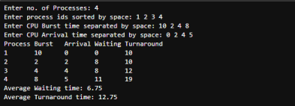

**PRACTICAL - 7**

**ROLL NO: SCS2526051**

**AIM: PYTHON APPLICATION TO SIMULATE PROCESS SYNCHRONISATION USING SEMAPHORRE**

**CODE:**

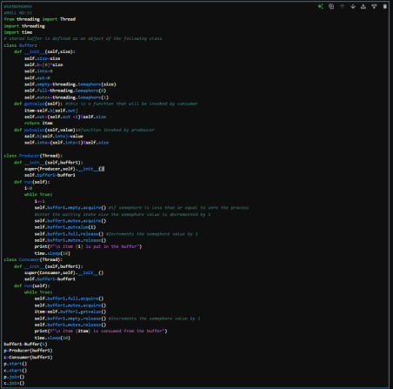**OUTPUT:**

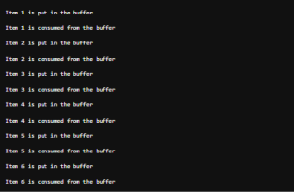

PRACTICAL - 8, 9, 10, 11

ROLL NO: SCS2526051

NAME: SREENATH SHANKARAN NAIR

AIM:A) LINUX BASIC COMMANDS

B) SHELL SCRIPTING 1: Write a shell script to perform the following commands on the current working directory 1. Long listing of all files in the pwd

2. To display the current system date

3. Count the number of lines, words, bytes, of the files 4. To display the current user

START ORACLE VIRTUALBOX

THEN CLICK ON NEW TO ADD UBUNTU

THEN ADD THE DISK IMAGE IN ISO IMAGE



THEN PRESS START BUTTON



THEN IT WILL SHOW THE LOG IN PAGE



THEN ENTER THE PASSWORD= “changeme”.

IT WILL SHOW YOU THE LINUX SOFTWARE



PWD COMMAND - IT WILL SHOW THE PRESENT WORKING DIRECTORY

CD COMMAND - IT WILL CHANGE DIRECTORY

LS COMMAND - IT WILL LIST ALL THE FILES AND DIRECTORIES

LS -L COMMAND - IT LIST DIRECTORY IN A BETTER FORMAT

LS -A COMMAND - IT LISTS ALL THE FILES WITH HIDDEN FILES

EXECUTION:



WHOAMI - ITS RETURNS THE CURRENT USERNAME MKDIR DIR1 - ITS MAKES A NEW DIRECTORY WITH DIRECTORY NAME DIR1

TO CHECK IF ITS MADE OR NOT TYPE COMMAND LS EXECUTION:



CAT EXAMPLES.DESKTOP - IT SHOWS THE CONTENT IN THAT PARTICULAR FILE





Echo - it will print the content you want in any file you wish



To merge call files into one

Cat file1.txt file2.txt file3.txt > combinedfile.txt

“>” this sign is used to enter content in a new file



To add a new line in the existing file

Echo “This is a new line” >> combinedfile.txt

Echo “ Yet another new line” >> combinedfile.txt

“>>” this sign is used to print the content in an existing file To check the number of lines, character, words, bytes

Command: cat combinedfile.txt | wc -l

cat combinedfile.txt | wc -m

cat combinedfile.txt | wc -w

cat combinedfile.txt | wc -c



To move the file to another directory

Command: mv file1.txt dir1



To copy the file to another directory

Command: cp file2.txt dir2

cp *.txt dir2 (this will copy all the files extensions with txt to dir2) 

To remove a file or directory

Command: rm file3.txt

rm dir3



To make the file zip and unzip

Command: gzip examples.desktop

gunzip examples.desktop



To show the contents of the file part by part

Command: more fileex.txt

less file.txt (the contents are showed on the other file you need to press q to come out of it







To see the head contents and tail contents

Command: cat fileex.txt | head

cat fileex.txt | tail



To see the patterns use GREP command

Command: grep Example fileex.txt

grep -i Example fileex.txt (This will show the all contents ignoring case )

grep -c Example fileex.txt ( this will give the count of the word repeated )

grep -ic Example fileex.txt( this will give the count of the word repeated ignoring case)





*Chmod*- To convert a normal file into executable file and give permission to various users

*Every file in linux is gives 3 permission to*: (read, write , execute (rwx))

Honor of the file : Honour is represented by a character u Users of the file: A grp or user is represented by character

Others: It is represented as o

All three are represented as a

We can use + to add permission and – to remove permission For example: If we want to give a permission to a grp : Code: chmod g+w file2.txt



SHELL SCRIPTING:

Q: quit a shell

Wq: To quit the shell mode

K: To go to the upper line

J: To go to the lwer line

h: To go toward left character

l: To go toward right character

line

i: to insert at the current location

I : To insert the text at the beginning of the current line a: To insert a text after the current location

A: To insert text at the end of a current location

o: To create a new line for text entry below the cursor O: To create a new line for text above the cursor

X:To delete a character at before the current position dw: Delete a word starting from cursor

d$: Delete from current positon to end of the line

Dd:Delete a complete

#What is shell script?

It is different commands written as batch for execution..The ss will ensure all commands run one after another and the output is shown

#Creation of scriptshell

Vi script1.sh ( all shellscript have extension of sh) #We come inside a vi- editor

Type i (for insertion)

Write all commands

Click esc

Type –wq

Arithmetic Operators

Addition: +

Subtraction: -

Multiplication: \*

Division: /

Comparison Operators

-eq = Equal to

-lt = Lesser than

-le = Lesser than or Equal to

-gt = Greater than

-ge = Greater than or Equal to

-ne = Not equal to

Conditional Statements (if, elif,else) Syntax:

if [condition]

then

statements

elif [condition]

statements

else

statement

fi

Switch - Case Statement (Case Statement) Syntax:

case value in

pattern “1”)

statements

;;

pattern “2”)

statements

;;

pattern “3”)

statements

;;

pattern *)

statements

;;

esac

done

Looping Statement

While

Syntax

while [condition]

do

Statements

done

Until: Until execute when the condition is true it will stop Syntax:

until [condition]

do

statements

done

For

Syntax:

for loopvariable in [range]

do

statement

Done

Break: It will stop iteration and will come out of the loop Continue: Current iteration is stop then it will execute

PRACTICAL - 8B

Write a shell script to perform the following commands on the current working directory

Long listing of all files in the current working directory[ls –l] To display the current system date [date]

To count the no of lines ,words and no of bytes of the file ex.txt [ ] To display the current user [whoami]







PRACTICAL- 9

ROLL NO: SCS2526051

NAME: SREENATH SHANKARAN NAIR

AIM: SHELL SCRIPTING 2: Write a shell script to accept a number and display the summation of the number

Enter VI script

CODE:



OUTPUT



PRACTICAL - 10

ROLL NO: SCS2526051

NAME: SREENATH SHANKARAN NAIR

AIM: SHELL SCRIPTING 3 :Write a shell script to accept the total marks and out of marks and calculate the percentage and display the grade of the student

Enter VI script

CODE:

OUTPUT



PRACTICAL - 11

ROLL NO: SCS2526051

NAME: SREENATH SHANKARAN NAIR

AIM: SHELL SCRIPTING 4 : Write a menu driven shell script to perform various arithmetic operations like addition, subtraction, multiplication and division on two numbers as per user’s choice. (Use case statements )

Enter VI script



CODE:



OUTPUT:



